***ACTIVITY 3.1: -***

Question-1: - Find genres of books including duplicates

Answer: - select genre from books;

Question-2: - Find genres of books excluding duplicates

Answer: - select distinct(genre) from books;

Question-3: - Find all horror books with alias booktitle for title.

Answer: - select id, title as booktitle, pagecount,genre,authorid,pubid from books where genre='Horror';

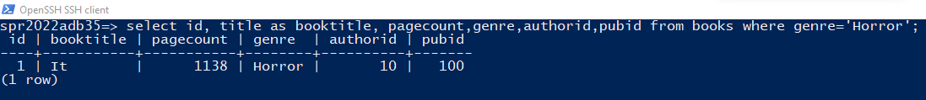

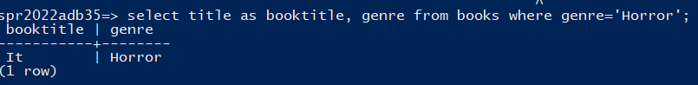

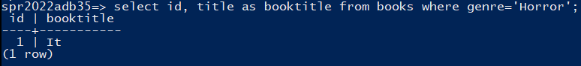

Question-4: - Find the languages of all editions of “it”.

Answer: - select distinct lang, edition, title from books,editions where books.id = editions.bookid and title='It';

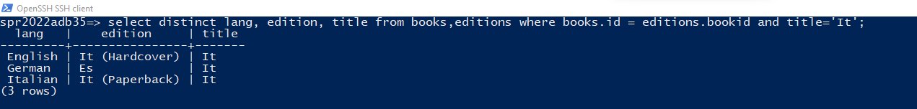

***ACTIVITY-3.2(a) Aggregates: - Try a few queries***

Question-1: - Try the select query

Answer: - select max(pagecount) from books;

Question-2: - Adding where clause to question-1.

Answer: - select max(pagecount) from books where genre = 'Drama'

Question-3: - select query with error

Answer: - select title, max(pagecount) from books where genre='Drama';

It gives an error message as given below: -

spr2022adb35=> select title, max(pagecount) from books where genre='Drama';

ERROR: column "books.title" must appear in the GROUP BY clause or be used in an aggregate function

LINE 1: select title, max(pagecount) from books where genre='Drama';



This error can be resolved by adding the group by clause as given below: -

select title, max(pagecount) from books where genre='Drama' group by title;

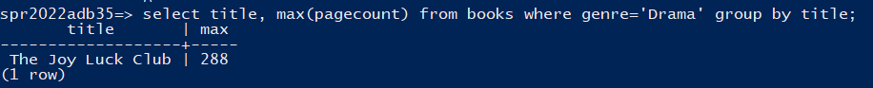

***Activity 3.2(b) Aggregates: Average and Max***

Question-1: - Example instance for different averages

Answer: - Both of these queries will yield different results when there is a duplicate entry for pagecount.

In this case, there is a duplicate value as highlighted in the screenshot below: -

Pagecount-224 for book titles September love and The nickel boys.

This means when distinct pagecount was not used for calculating the average of pagecounts, then the result was 432.4667(approx.) whereas when distinct pagecount was used, then the result was 447.357 (approx.).

This is also present in the screenshot presented on the next page.

Question-2: - can max(attribute) return different values or not?

Answer: - No, the value of these queries will always be the same and that is equal to the highest value of the attribute present in the table.

There is only one condition where the max(attribute) query can return different results (when distinct is used and when not) is only when a group by clause is used. This is because group by does a grouping according to the attribute and that can vary the result.

This can also be proved by using the screenshot below: -

***ACTIVITY 3.3(A): - INSERTS***

Question-1: - Insert query for books

Answer: - insert into books values(16,'Paper Towns',420,'Young adult',24,100);

This is also highlighted in the screenshot below along with the select * to confirm the insertion.

Question-2: - Insertion using the /COPY command

Answer: - The first step is to create the csv file on the local PC.

The file’s contents are attached below along with the file: -





After this, we must copy this file from local machine to the remote machine (linux.pdx.cs.edu). This will be done by the following command: -

scp books-copy.csv [parth2@131.252.208.103:/u/parth2/DBMS/bookschema](mailto:parth2@131.252.208.103:/u/parth2/DBMS/bookschema)

After this, we will use the following command to copy the contents of the file into the database: -

\copy books from books-copy.csv with csv header

The output along with the select command highlighting the inserted field is given below: -

***Activity-3.3(B): -Default and null values***

Question: - add default value to age in author, insert a author without an age and query to return author added above

Answer: - The ***first task*** to be done is to add a default value to the author’s age in author table.

This will be done by the following query: -

alter table authors alter column age set default 20;

This change can be seen in the screenshot below: -

The ***second task*** to do is to insert an author without an age so that it sets to the default age. This will be done by the following query: -

insert into authors values(24, 'John Green');

To verify the insertion, we have the screenshot containing the highlighted insertion.

The ***third task*** to complete is to write a select query to return the author added in the second task: -

select * from authors where age=20;

***ACTIVITY-3.4: - Updates and Null Values***

Question-1: - Update the tuple inserted in 3.4 to set their age to null?

Answer: - update authors set age=NULL where id = 24;

The screenshot for this query is given below: -

Question-2: - Write a query to find authors where age is null?

Answer: - select * from authors where age is null;

The screenshot for the same is given below: -

Question-3: - Write a query to find average age of authors? How do null values affect this average?

Answer: - select avg(age) from authors;

The result for this query is given in the screenshot below: -

We can also find the round value of the average age using the following query:

select round(avg(age)) from authors;

The screenshot for the same is given below: -

Null values have no effect on the average age of authors. This is because NULL values are not included by the AVG aggregate function when calculating the average.

***ACTIVITY-4.1: - RA – Select Activity***

Question: - Find all books with pagecount>1000

Answer: -

The equivalent SQL command is: -

Select * from books where pagecount>1000;

***ACTIVITY-4.2 RA-Project Activity***

Question-1: - Find all names of books with pagecount>1000.

Answer: -

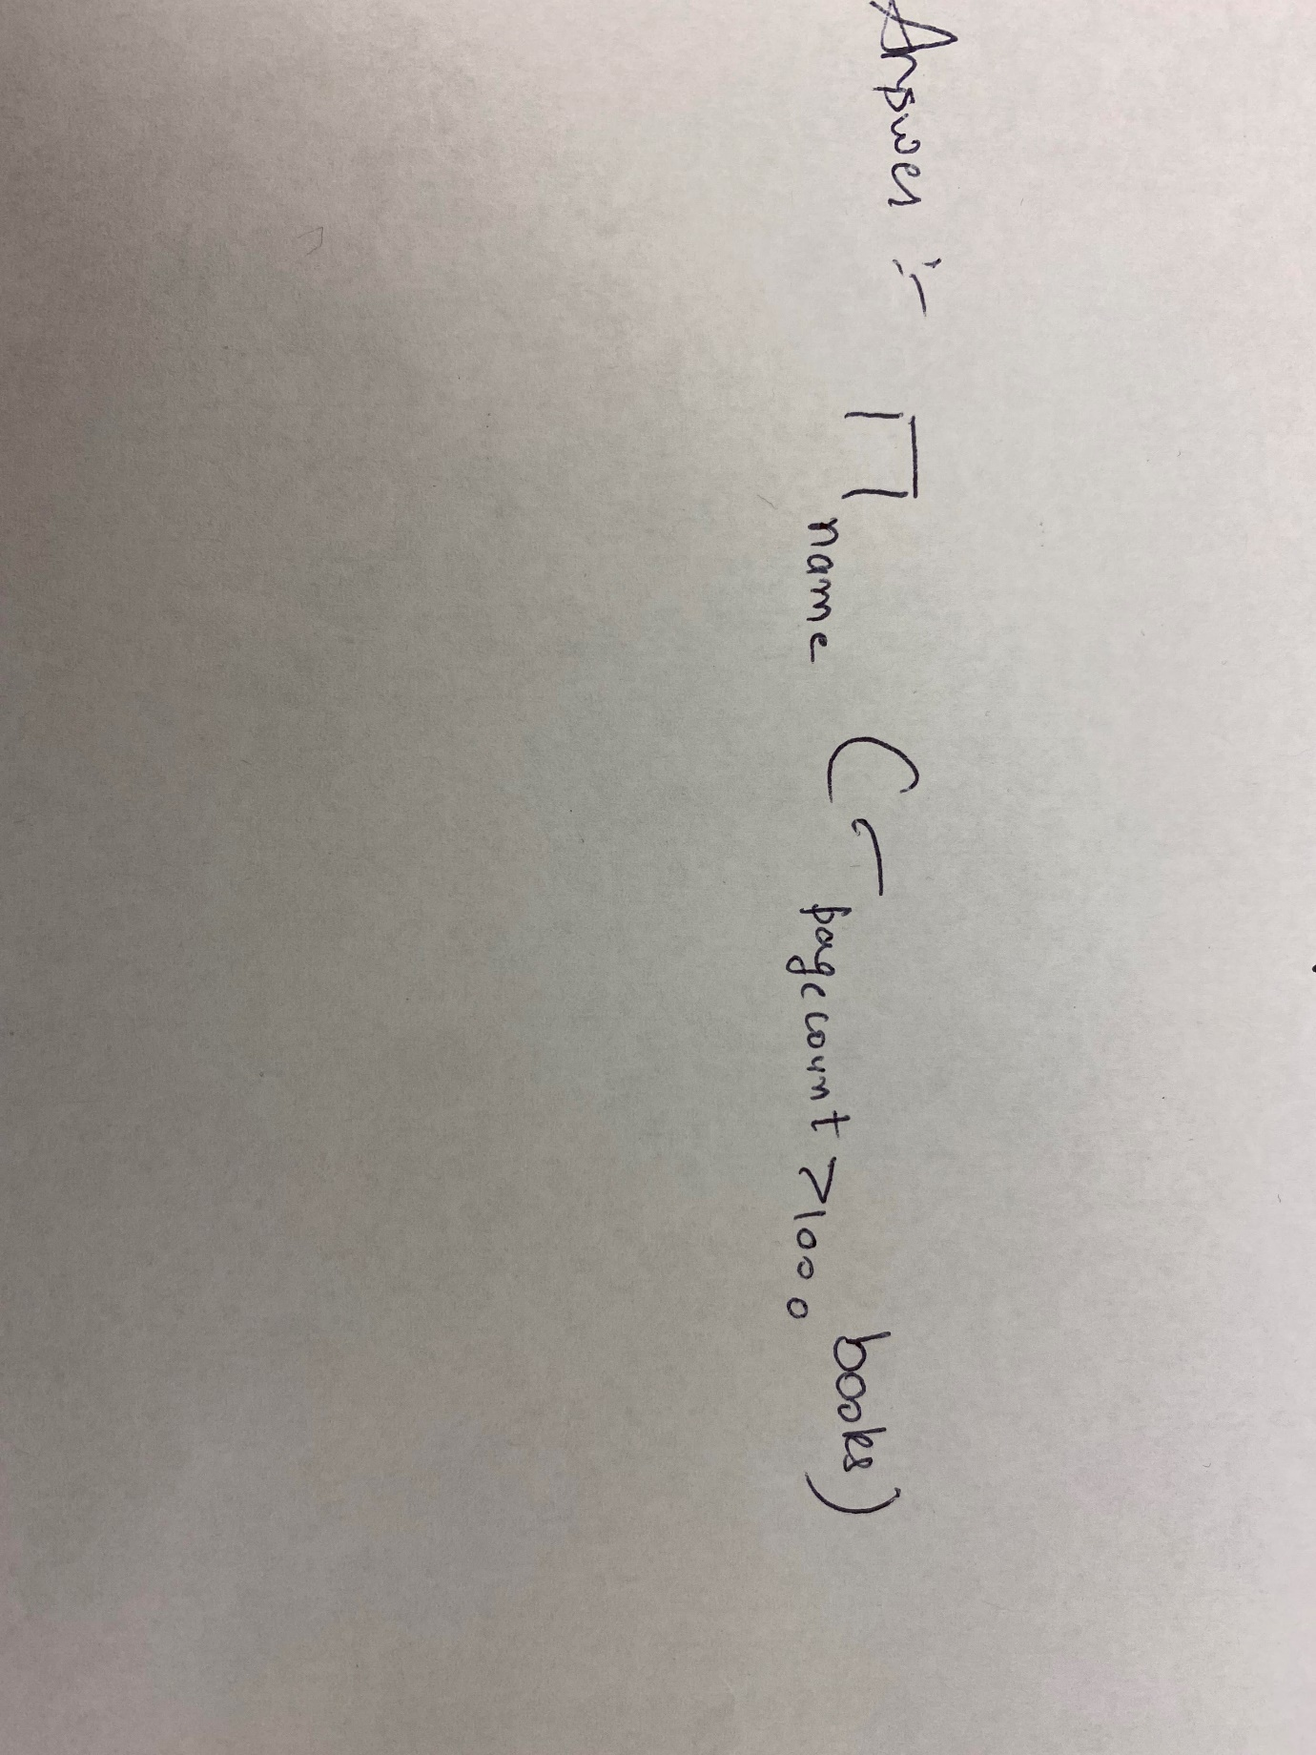

The equivalent SQL statement is: -

Select name from books where pagecount>1000;

***ACTIVITY-4.3-RA-Join Activity***

Question: - Find the names of the author with books of pagecount>1000.

Answer: -

The equivalent SQL query is: -

select name from authors A JOIN books B on A.id = B.authorid where pagecount>1000;

